Module 1a

Software Layout

# Starting Lego Mindstorms

## Desktop Icon

The icon if available on your desktop is shown below.

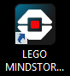

## Start Menu

The icon can be found under “Lego Mindstorm EV3”

# Opening Screen

The opening screen will depend on your version of the software.

## Home Edition

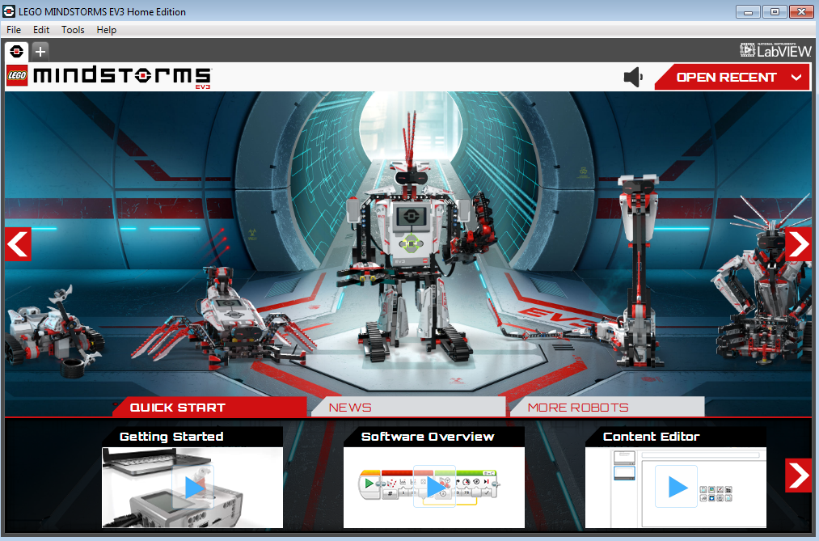

## Education Edition

# Projects

## Starting a Project



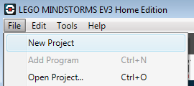

## Project Screen

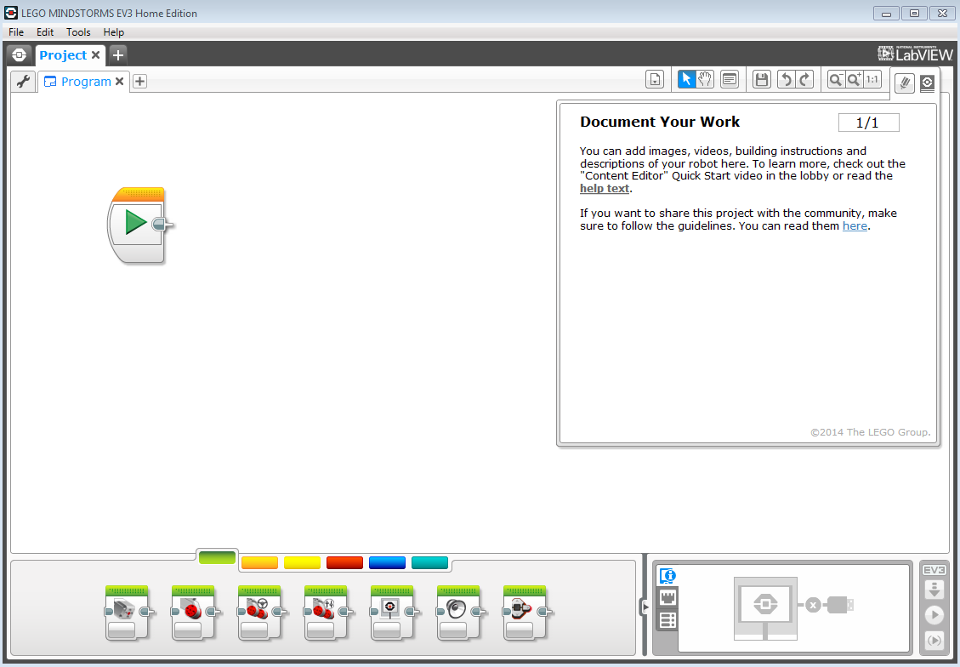

Project Name

Program Name

Click here to minimize

“Document Your Work”

## Saving a Project

### Name your Program

1. Double click the name of your program to rename it.

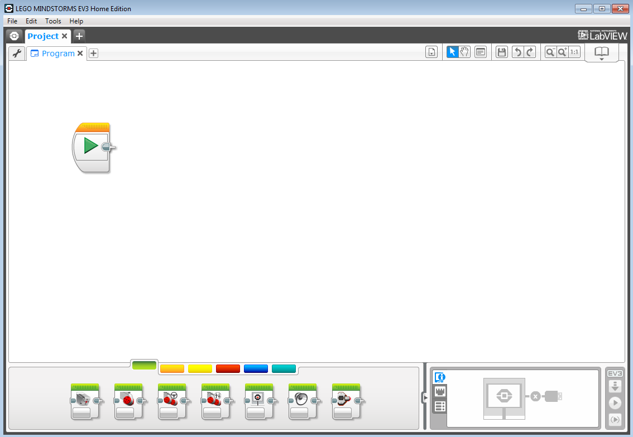

1. Make sure the whole word is highlighted

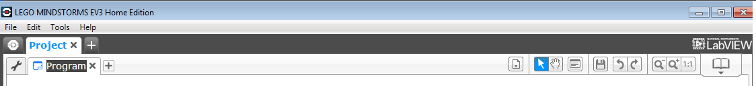

1. Type the new name and press Enter or click somewhere else on the screen.

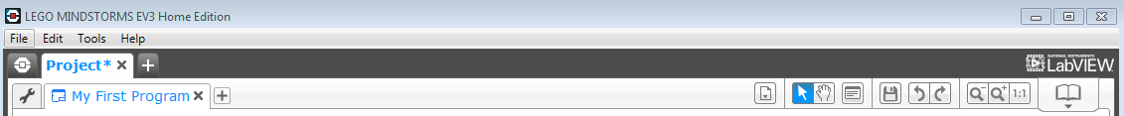

### Save your Project

You can save your project one of the two ways indicated below.

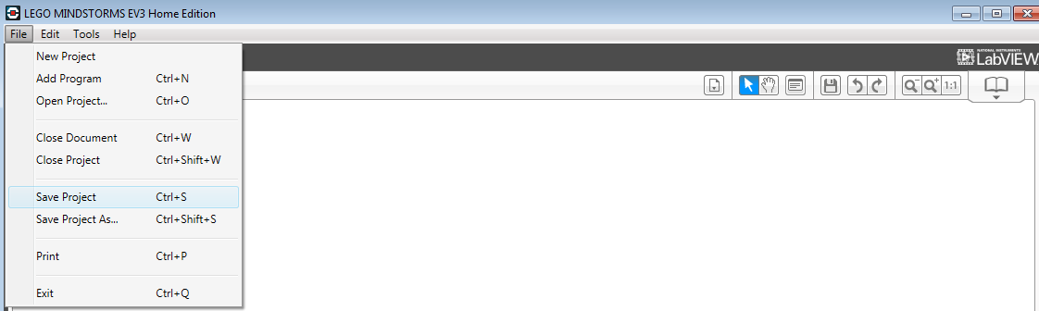

## Tools

The tools available at the top right of the screen are explained below

Change Content Editor to Edit Mode

Zoom In

Redo

Comment Tool

Select Tool



Exit Content Editor

Original Zoom

Zoom Out

Undo

Pan Tool

Program List

# Blocks

## Adding Blocks

Your program will be made up of blocks located at the bottom of the screen. There are 2 ways to place blocks.

* CLICK-HOLD, DRAG, RELEASE
* CLICK, DRAG, CLICK

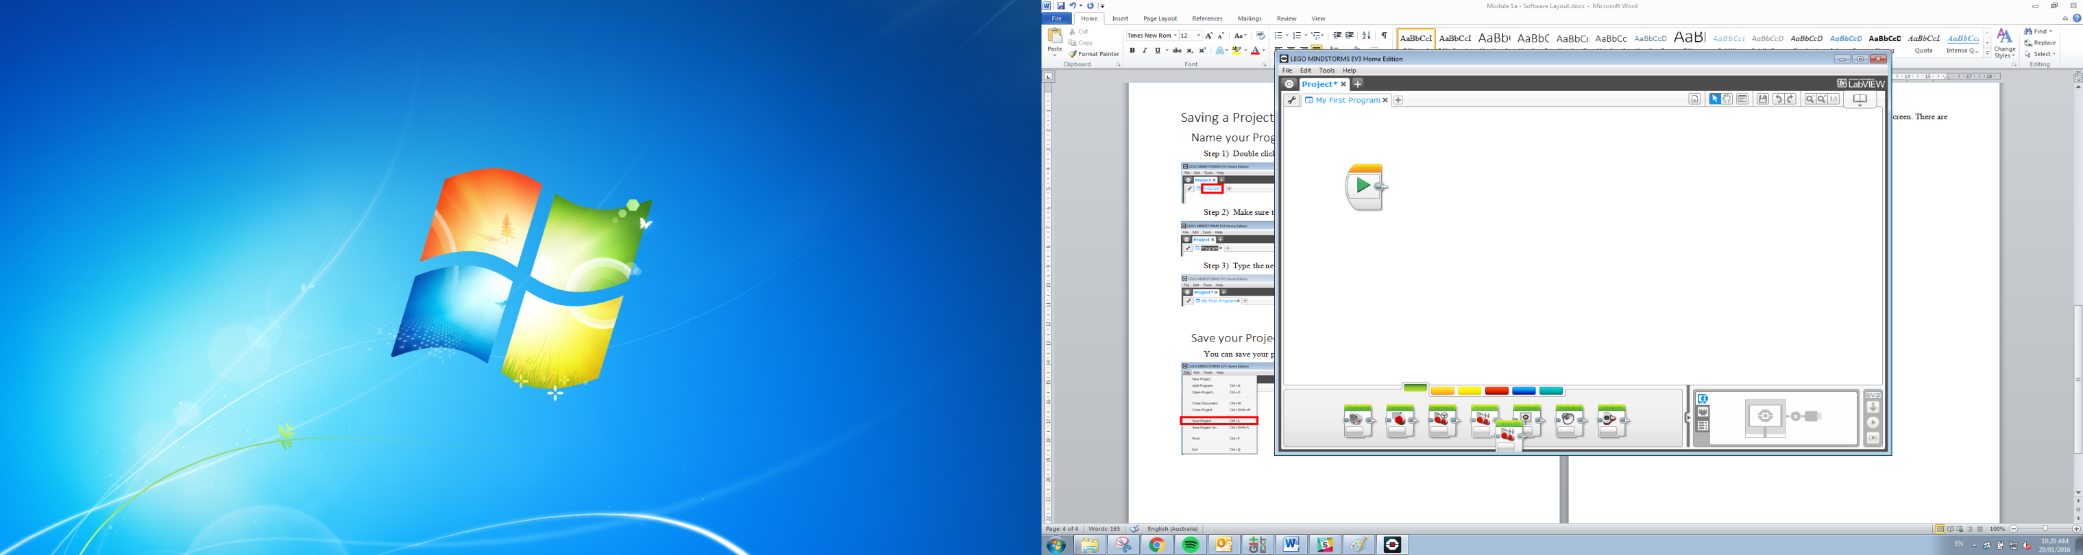

CLICK

When dragging the block close to another block, a grey square will tell you where the block will connect.

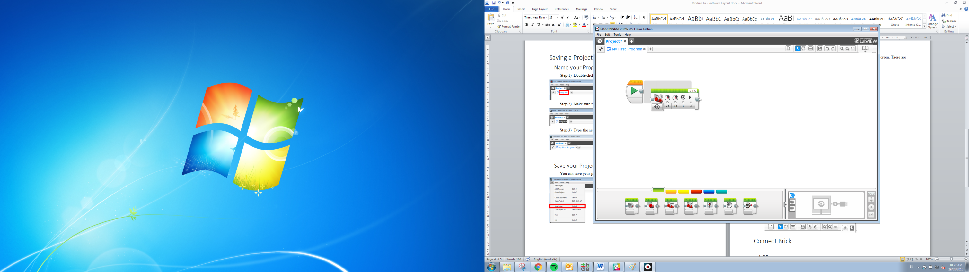

DRAG

After release the block will connect where the grey square was.

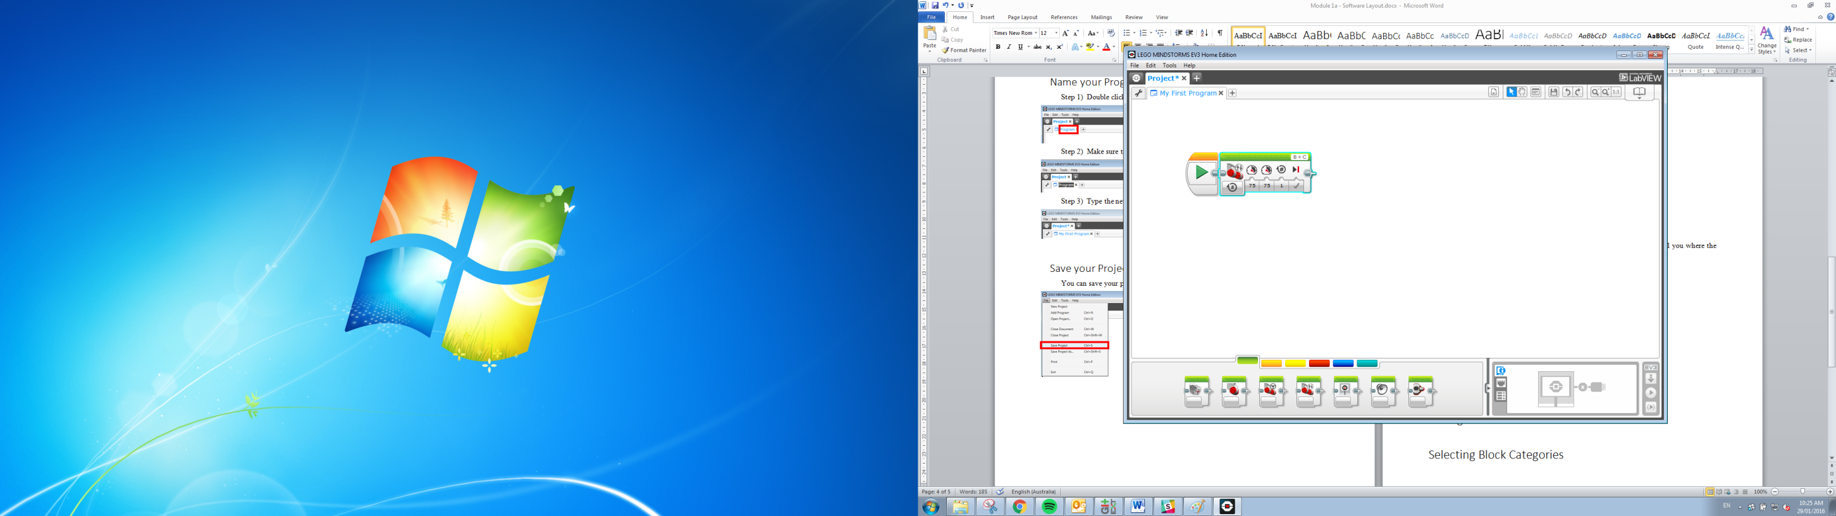

RELEASE

## Moving Blocks

Once a block is placed and you want to move it. You have to select the dotted section on the block and use the CLICK-HOLD, DRAG, RELEASE technique. Here are some examples of dotted sections on different blocks.

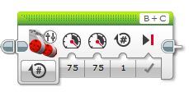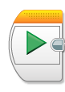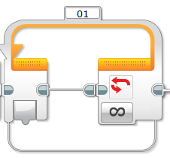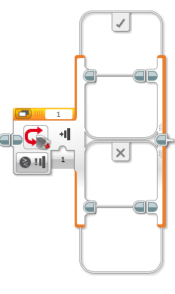

## Removing Blocks

You can remove blocks by moving to the block bar shown below or selecting the block and pressing delete on your keyboard.

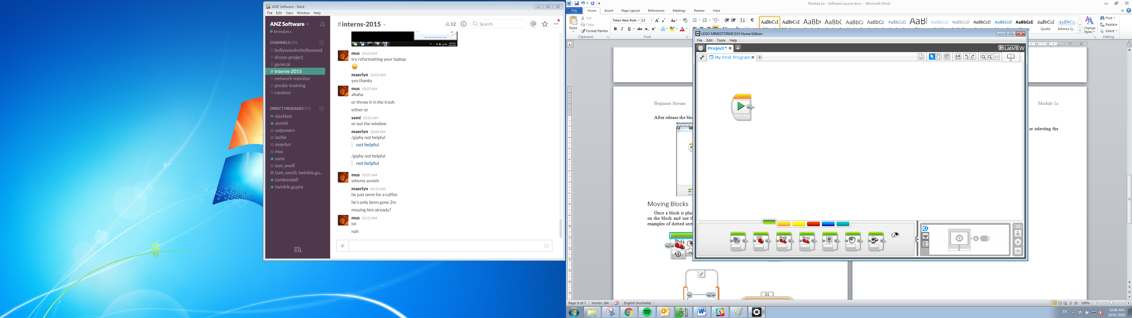

## Inactive Blocks

Blocks that are not connect to the Play block and are not part of the program are greyed out.

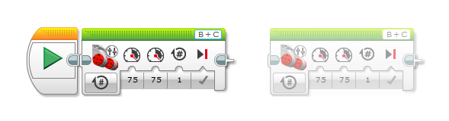

## Wiring Blocks

Blocks don’t have to be side by side to be connected. You can drag a wire from one to the other to connect them. Use the CLICK-HOLD, DRAG, RELEASE technique to connect the blocks.

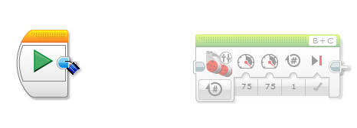

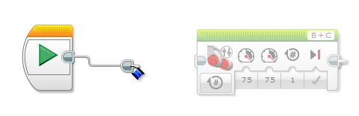

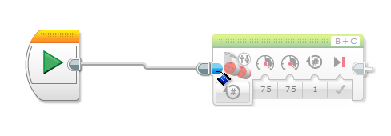

## Block Categories

Blocks are organised into different categories. You can change them by selecting the coloured tabs shown below. Here are examples of the 2 categories you will mostly use.

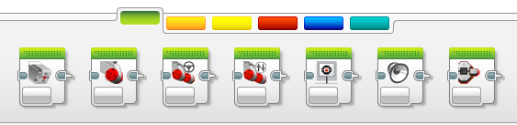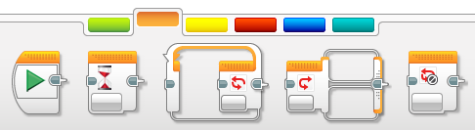

# Connect the EV3 Brick

The brick can be connected in several ways. Here I will explain the 2 most commonly used.

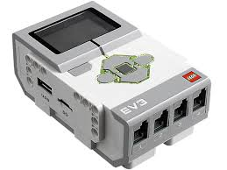

## USB Cable

The cable is provided in the Educational kit. The cable ends are shown below.

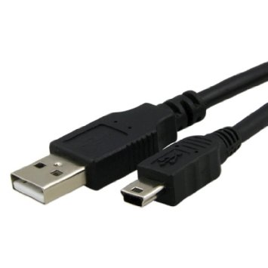

The small end plugs into the Brick port labelled “PC” and the larger end into the computer.

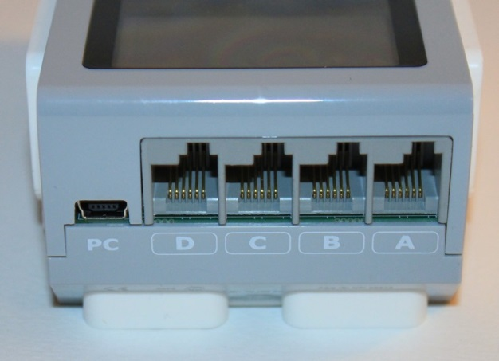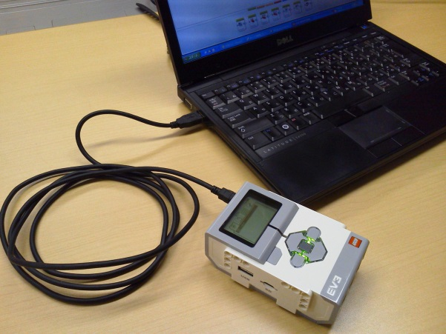

## Bluetooth

This connection allows a wireless operation but involves more steps to connect.

1. Enable the Bluetooth on the EV3.

Navigate to the “Settings” tab.

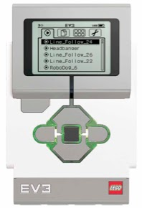

Settings Tab

Press to navigate right

Tick the Bluetooth option and make sure “iPhone/iPad/iPod” option is not selected.

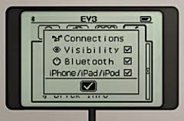

Tick this box.

Do not tick this box.

1. Search for the Brick on the computer.

The searching is done in the bottom right of the screen.

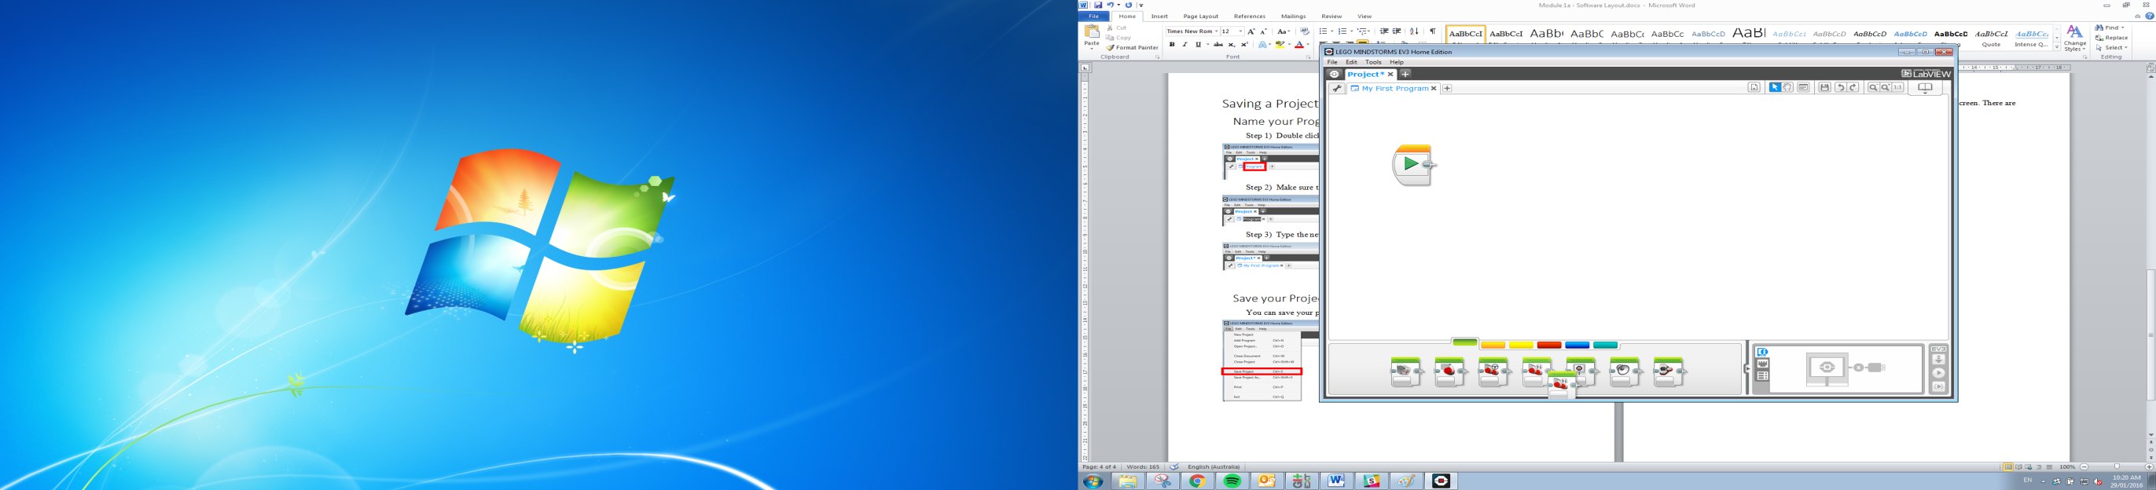

Select the “Available Bricks” option.

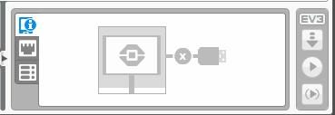

If your EV3 does not come up in the menu press the refresh button.

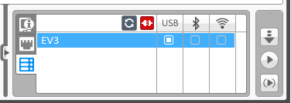

Refresh

1. Connect the Brick

Tick the box to connect through Bluetooth.



Bluetooth connect

1. Follow the given prompts to set the password and connect the Brick.

# Download and Play Project

These actions are all completed in the very bottom far right of the screen.

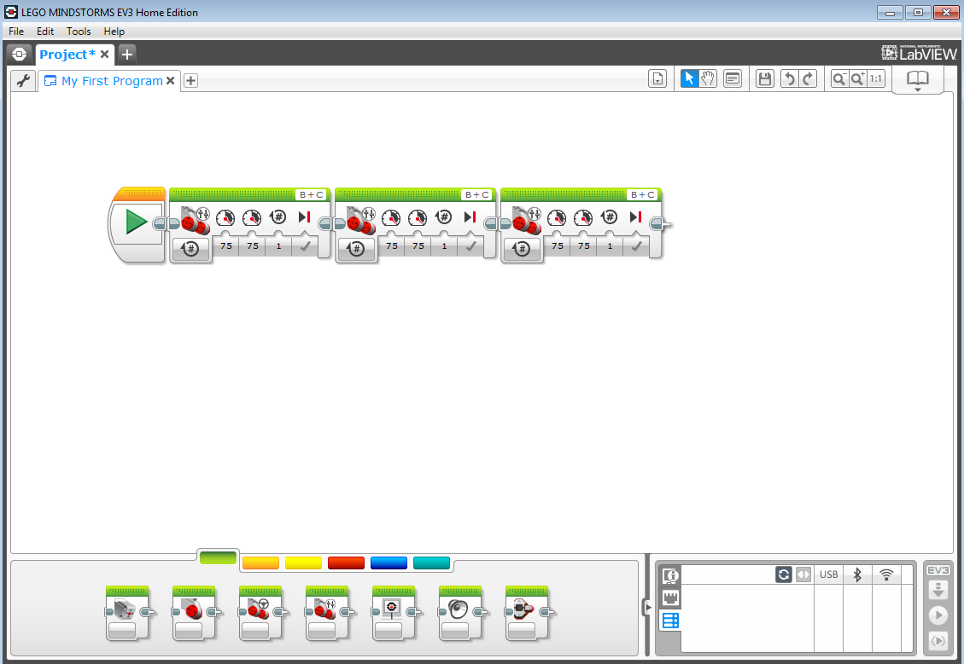

## Downloading the Project

To download a project, select the “Download” button.



## Playing a Program

### Stopping a Program

Before you run a program you need to know how to stop a program. Press the top left button to exit any program that is running.

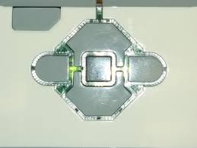

### Download and play

This will download the project and play immediately after.



### Play a Downloaded Program

Projects that have been downloaded can be found in the “File Navigation” tab.

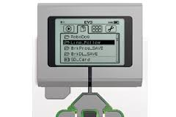

Navigate through the Project names and select the project with the middle button to expand and see the Programs.

Select a Program to run it.

### Recently Played List

This list contains the programs that have been run already in order from most recent to oldest.



Now you are ready to start programming!